Grym parameter values for Subareas 48.1, 48.2 and 48.3.

Thanassekos S., Reid K., Kawaguchi S., Wotherspoon S., Maschette D., Ziegler P., Welsford D., Watters G., Kinzey D., Darby C., Trathan P., Hill S., Earl T. and?…

**Abstract**

As part of the revision of the krill management approach, an updated set of parameter values is required for the Grym to perform projections in Subareas 48.1, 48.2 and 48.3. Where applicable, Subarea-specific values are set to account for the different dynamics in each Subarea. Given the scope of the task, some parameter values are found in the scientific literature while others correspond to the current expertise from all involved CCAMLR scientists.

**Grym parameters**

The table below summarizes the parameters and their values as used in the Grym krill projections for Subareas 48.1, 48.2 and 48.3. Following the table, sections of text provide either justifications or references for the values chosen, when those values differ from the original GYM calibration (Constable and de la Mare, 1996).

Table 1. Grym parameters and their values in each Subarea. Values referred to as ‘This study’ may be derived from published studies whose references are given in the text.

|  |  |  |  |  |  |
| --- | --- | --- | --- | --- | --- |
| Parameter | All areas | 48.1 | 48.2 | 48.3 | Reference |
| First Age class | 0 |  |  |  | Constable and de la Mare (1996) |
| Last Age Class | 7 |  |  |  | Constable and de la Mare (1996) |
| t0 | 0 |  |  |  | Constable and de la Mare (1996) |
| L∞ | 60mm |  |  |  | Constable and de la Mare (1996) |
| k |  | 0.48 | 0.45 | 0.55 | This study |
| Start growth period (dd/mm) |  | 21/10 | 21/10 | 09/10 | This study |
| End growth period (dd/mm) |  | 12/02 | 05/02 | 27/02 | This study |
| Weight-length parameter - A (mg) | 0.0043 |  |  |  | Siegel (2016) |
| Weight-length parameter - B | 3.2446 |  |  |  | Siegel (2016) |
| Min length, 50% mature | 26mm |  |  |  | This study |
| Max length, 50% mature | 30mm |  |  |  | This study |
| Range over which maturity occurs | 6mm |  |  |  | This study |
| Start of spawning season (dd/mm) | 15/12 |  |  |  | Kawaguchi (2016) |
| End of spawning season (dd/mm) | 15/02 |  |  |  | Kawaguchi (2016) |
| Monitoring interval (dd/mm) | 01/01 to 15/01 |  |  |  | This study |
| Recruitment function | *Proportional* |  |  |  | Constable and de la Mare (1996) |
| Mean proportional recruitment |  | 0.188/0.425* | 0.296 | 0.314 | CCAMLR Secretariat (2021) |
| SD of proportional recruitment |  | 0.236/0.170* | 0.260 | 0.278 | CCAMLR Secretariat (2021) |
| Min length, 50% Selected | 30mm |  |  |  | This study |
| Max length, 50% Selected | 35mm |  |  |  | This study |
| Range over which selection occurs | 11mm |  |  |  | This study |
| Fishing Season (dd/mm) | 01/12 to 30/11 |  |  |  | This study |
| Reference Date (dd/mm) | 01/10 |  |  |  | This study |
| Reasonable upper bound for Annual F | 1.5 |  |  |  | Constable and de la Mare (1996) |
| B0 log SD | 0.685 |  |  |  | This study |
| Target Escapement | 75% |  |  |  | Constable and de la Mare (1996) |

*Values given for 481N/481S, see CCAMLR Secretariat (2021) for details.

*Von Bertalanffy parameter k*

This parameter was set at 0.45 following Constable and de la Mare (1996) for Subarea 48.2 and at 0.48 for Subarea 48.1 in order to achieve similar Age-0 growth rates in these areas while accounting for the different growing season length (see section below). *k* was set at 0.55 for Subarea 48.3 given the known faster growth of krill in the region (Reid, 2001).

*Growth period*

The calibration of the growth period was carried with the intent to reflect the different periods of enhanced primary productivity in each Subarea. To do so, Satellite-derived Photosynthetically Active Radiation data was downloaded from the Giovanni portal (<https://giovanni.gsfc.nasa.gov/giovanni/>) for each Subarea (MODISA_L3m_PAR_8d_4km v2018, unit: Einstein m-2 day-1) from 2002-07-04 to 2020-04-29, Time Series, Area-averaged). For each Subarea, a loess regression was fit through data points, and a threshold of 25 Einstein m-2 day-1 was determined to result in a representative krill growth period in each Subarea (Fig. 1). As a result, growth periods in the Grym were set as ranging from: 21 October to 12 February in Subarea 48.1, 21 October to 5 February in Subarea 48.2, and 9 October to 27 February in Subarea 48.3.

Figure 1. Eight-day area-averaged satellite-derived Photosynthetically Active Radiation (Einstein m-2 day-1) from 2002-07-04 to 2020-04-29 in each Subarea (coloured dots) and loess regression curves (coloured lines). Using a threshold of 25 Einstein m-2 day-1 was determined to result in a representative krill growth period in each Subarea.

Using the chosen Von Bertalanffy parameters, growing seasons and reference date within the Grym’s *vonBertalanffyRAL* function produces the growth curves shown in Figure 2.

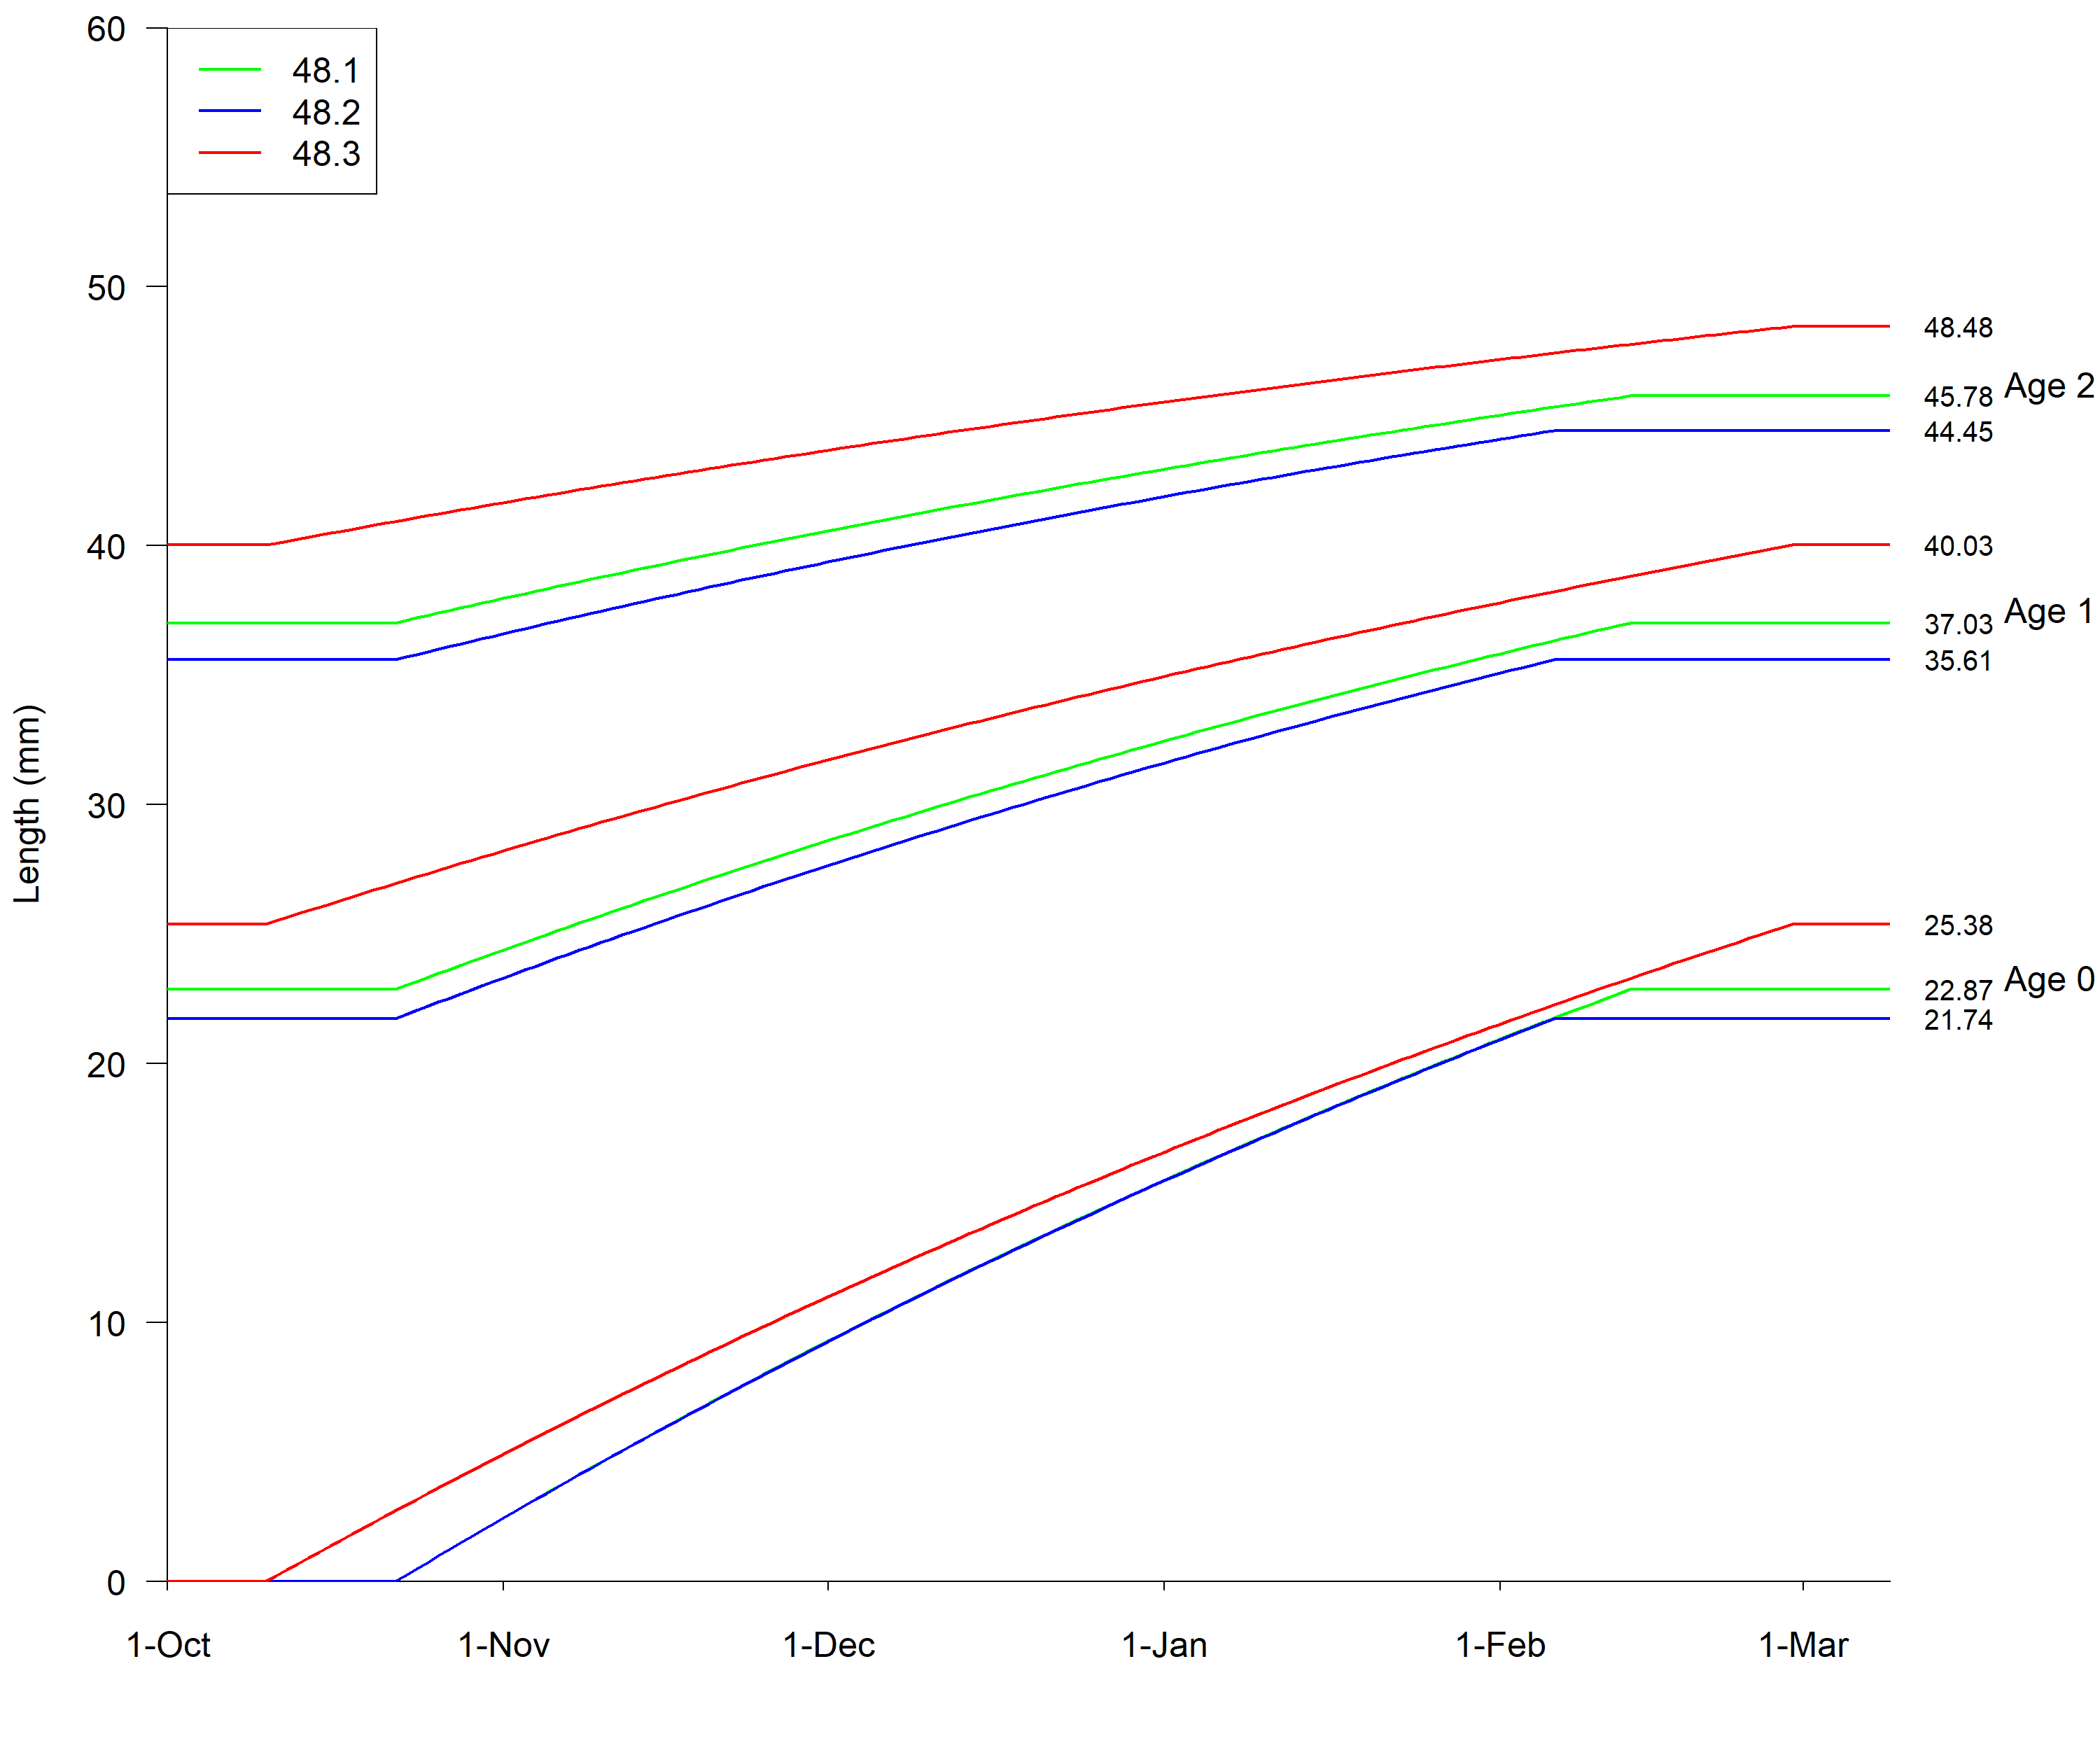

Figure 2. Growth curves for age classes 0-2 in each Subarea produced with the chosen parameter values within the Grym’s *vonBertalanffyRAL* function.

*Weight-at-length relationship*

Based on a collation of krill weight-at-length relationships (Siegel, 2016) the average weight (wet weight, mg) to length (total length, mm) relationship (W=A×LB) is computed with parameters: A=0.0043 and B=3.2446.

*Maturity*

Maturity was calibrated using the SISO (*i.e.,* observer data, since 2010) maturity and length data. Based on the proportion of mature individuals per 2mm size bin in each Subarea (Fig. 3), the following parameter values were set:

Min length, 50% are mature: 26mm

Max length, 50% are mature: 30mm

Range over which maturity occurs: 6mm

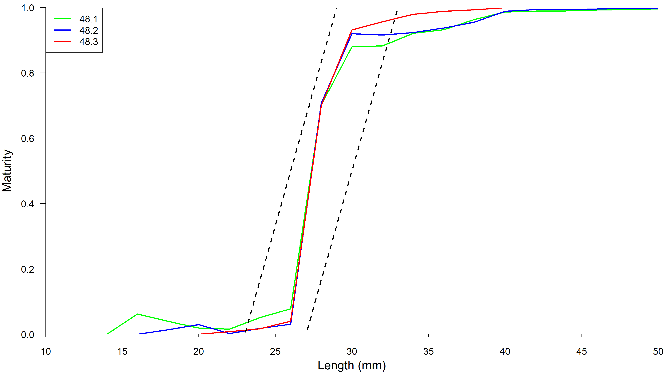

Figure 3. Maturity ogives in each Subarea (SISO data, coloured lines) and range as produced with chosen parameter values within the Grym’s *rampOgive* function (black).

*Spawning season*

The spawning season was set to occur from 15 December to 15 February following Kawaguchi (2016). In the Grym, this is the period where the spawning stock biomass is calculated based on the total biomass and maturity ogive.

*Monitoring interval*

The monitoring interval (used to report biomass each year in the Grym) was set as occurring between 1 January and 15 January.

*Recruitment*

In line with Constable and De la Mare (1996), recruitment was simulated in the Grym using proportional recruitment estimated with a Beta distribution. The mean and standard deviation of proportional recruitment in each Subarea was estimated using the SISO data and included a distinction between 481N and 481S within Subarea 48.1 (CCAMLR Secretariat, 2021) as:

In Subarea 48.1:

481N: µR=0.188; σR=0.236

481S: µR=0.425; σR=0.170

In Subarea 48.2: µR=0.296; σR=0.260

In Subarea 48.3: µR=0.314; σR=0.278

*Gear selectivity*

Gear selectivity was calibrated to match results from Krag et al. (2014) by setting the following parameter values (Fig. 4):

Min length, 50% Selected: 30mm

Max length, 50% Selected: 35mm

Range over which selection occurs: 11mm

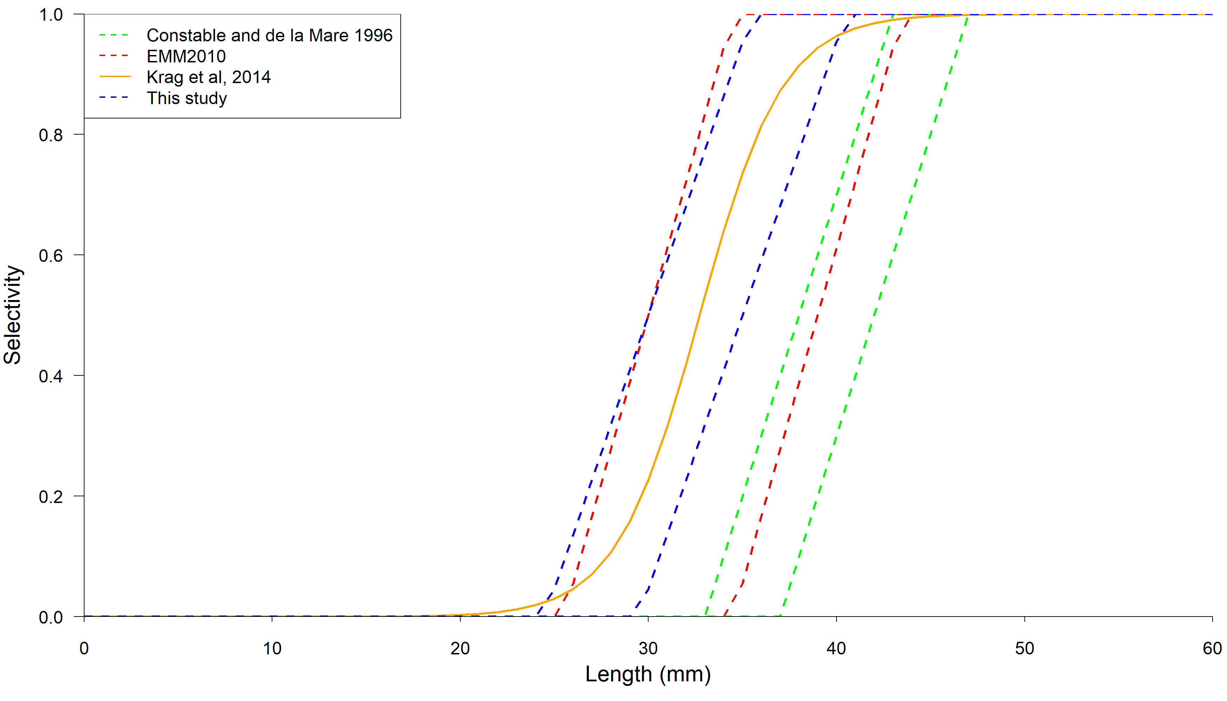

Figure 4. Selectivity ogives ranges from a set of Grym/GYM calibrations and the published relationship (Krag et al, 2014).

*Fishing season*

Given the ongoing development of the fishery in these Subareas, the fishing season was set as year-round (1 Dec to 30 Nov).

*Reference Date*

The reference date defines the midnight before the first day of each modelled year, and any annual activity occurs relative to this date; any default annual summaries are reported relative to the reference date, and recruitment and advancement to the next age class occur on that day. The reference date was set as 1 October to match the beginning of the growing season.

*B0 log SD*

Estimates of B0 log SD range from 0.457 to 0.913 (Kinzey Ref – details). The mean of 0.685 was used here.

References

CCAMLR_Secretariat, 2021. Antarctic krill proportional recruitment indices (2010-2020) in Subareas 48.1-48.3.

Constable, A.J., de la Mare, W.K., 1996. A generalised model for evaluating yield and the long-term status of fish stocks under conditions of uncertainty. CCAMLR Sci. 3, 31–54.

Kawaguchi, S., 2016. Reproduction and Larval Development in Antarctic Krill (Euphausia superba). pp. 225–246. https://doi.org/10.1007/978-3-319-29279-3_6

Krag, L.A., Herrmann, B., Iversen, S.A., Engås, A., Nordrum, S., Krafft, B.A., 2014. Size Selection of Antarctic Krill (Euphausia superba) in Trawls. PLoS One 9, e102168. https://doi.org/10.1371/journal.pone.0102168

Reid, K., 2001. Growth of Antarctic krill Euphausia superba at South Georgia. Mar. Biol. 138, 57–62. https://doi.org/10.1007/s002270000425

Siegel, V., 2016. Introducing Antarctic Krill Euphausia superba Dana, 1850, in: Siegel, V. (Ed.), Advances in Polar Ecology. Springer International Publishing, Cham, pp. 1–19. https://doi.org/10.1007/978-3-319-29279-3_1